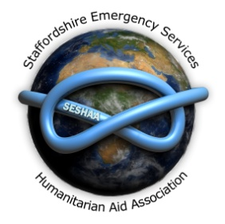

Staffordshire Emergency Services Humanitarian Aid Association

SESHAA Registered UK Charity 1070739

SESHAA Chair Alf Wilson and Vice Chair Chris Wood have since 2012, been heavily involved in the development of FIREAID, which has now received funding from the Department for International Development (DfID) the funding has helped in the creation of a FIREAID website, http://www.fire-aid.org/ both the Chair and Vice Chair are now members of the FIREAID Steering Group and two serving members of Staffordshire Fire and Rescue Service, Paul Radcliffe and Gary Dumighan are also members of the board. The Chair of SESHAA is also a member of the CFOA (Chief Fire Officers Association) liaison group looking into the endorsement of FIREAID and its projects by CFOA. The work that has been undertaken to date and the formation of FIREAID has now been recognised by a formal reception launch at the House of Lords (Westminster) which took place in June 2014.
By kind permission of the Lord Speaker, FIREAID hosted its launch event at the River Room, in the House of Lords on 5th June 2014. The reception, which was attended to full capacity, was hosted by Lord Dubs of Battersea and included representatives from political, diplomatic, fire and rescue, humanitarian aid and international spheres as well as FIREAID’s founding members. Guests included Gus Schaefer and Judith Stone of the Board of Trustees of Underwriters Laboratories - who work to advance fire safety technology and procedures - who travelled from the USA to attend the event.
Guests heard speeches from FIREAID Chair Jim Fitzpatrick MP, FIREAID Patron Lord Robertson of Port Ellen, President of the Chief Fire Officers Association Peter Dartford, and Director of the Eastern Alliance for Safe and Sustainable Transport (EASST) Emma MacLennan.
As Chair of the Commission for Global Road Safety, Lord Robertson focused on the emergency response to road traffic collisions and the vital role that fire services can play, given the right equipment and training, in reducing the number of global road deaths. Lord Robertson informed guests that if road fatalities continue to occur at the present rate, the total number of deaths recorded in the 21st century will be greater than the total number of deaths recorded during all the wars of the 20thcentury – a truly shocking figure, particularly given that road traffic collisions are preventable.
Peter Dartford, Vice President of CFOA, spoke of CFOA’s support of FIRE AID in recognising it as an association that promotes good practice in the delivery of emergency services aid in all its forms including development of written best practice guidance, promotes the work of its member, and acts as a general communications hub for requests for aid.
His endorsement was welcomed by the FIRE AID Steering Committee as an important step in its development. Guests also heard from Emma MacLennan, Director of EASST and a founder member of FIRE AID, who spoke about a recent project in Moldova and the impact it has had on the Moldovan Fire Service in support of the aims of the UN Decade of Action for Road Safety.

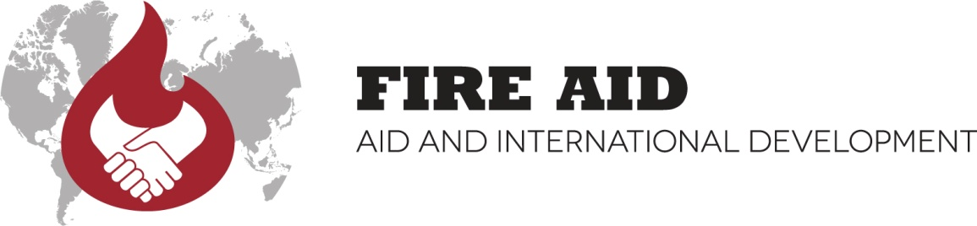
FIREAID is an association of UK charities and services with a mutual interest in providing ethical and sustainable donations of fire and rescue aid and training to developing countries. It was formed in 2012 by a group of like-minded organizations who have been operating for many years, successfully donating equipment, training and expertise to over 30 countries.
FIREAID is chaired by Jim Fitzpatrick MP and is managed by a Steering Committee of its founding members. It receives core funding from the UK Department for International
Development (DfID) in recognition of the vital role carried out by UK fire services and NGOs in delivering equipment and training to communities in need. Among other areas of work, FIREAID promotes best practice in the delivery of emergency services aid, manages an equipment database, and provides a forum for discussion on issues relevant to FIREAID.

Membership of FIRE AID is currently free and open to UK-registered charities and non-profits with the following benefits:
Most specialisations and industries have a collaborative body, which organisations with the appropriate background, experience or qualifications can join. What can your group gain by joining FIREAID? Will it help you’re Projects? Organisational or personal development? Here are some of the potential benefits that membership can offer.
Professional Recognition: Once you have demonstrated that your non profit organisation or service has the requisite qualifications, you may join FIREAID and add the name and logo to your organisations or services CV and business card. Membership shows that you have reached a certain level of expertise in your field, gives you more collaborative opportunities and adds to your credibility.
Fulfilling Corporate & social responsibility: Short-term costs that do not provide an immediate financial benefit to the service but instead promote positive social and environmental change. The re- use of redundant appliances and equipment to areas of the World in need.
Information and Advice: FIREAID have a website offering member’s password protected access to projects, the AID Handbook, news reports, updates, information, vehicles, equipment, and details of events.
Networking Opportunities: FIREAID can be useful for making new contacts, learning more about what’s happening in the AID sector. National exposure and conferences also offer excellent networking and project collaboration opportunities
Career Development: Continuous professional development (CPD) is essential if you want to forge a successful career. Some FIREAID Projects may offer personal development opportunities, which gives added professional credibility.

Jim Fitzpatrick MP spoke of his commitment to FIREAID and his admiration of UK fire-fighters who deliver aid internationally as volunteers, with Lord Robertson of Port Ellen, the patron of FIREAID and some of the guests looking on.

